# **Objection to Sustainability Appraisal/ Strategic Environmental Assessment (SA/SEA) and Habitats Regulation Assessment (HRA)**

## **Reasonable alternatives – distribution of development and opportunities at the Greetham**

In relation to the SA, it is considered that the SA has not correctly considered all reasonable alternatives in terms of the distribution of development and in particular has incorrectly assessed the impact of development at Greetham Quarry.

In this case the benefits of development at Greetham Quarry principally for residential uses but which would also provide for local employment use (and with the potential for associated green infrastructure and community access) as part of a planned mixed development was discounted too early in the site selection process and that the guidance suggest that a different approach should have been taken which recognises the importance of the need to make allocations to support the wellbeing of rural communities.

As highlighted in detail in our commentary on the Housing and Employment Site Selection Report (see below) the Sustainability Appraisal was based on the wrong site (GRE11/AECOM105/Former Phase 1 of Greetham Quarry). This has resulted in the incorrect scoring of the site in relation to its impact on the deciduous woodland that is actually outside of the site and would not be lost or prejudiced in any way, as assumed in the assessment. It was only this impact that prevented the site from passing through part 2a of the site selection process and hence be considered more fully in the SA.

In addition, the omission of the Landscape Capacity / Sensitivity layers from the SA (SA Appendix 1 paragraph 3.4) assessment means that the SA has not taken into account the findings of this research (which are set out below) but in this case highlighted that the site has a medium / low sensitively to development, and can deliver significant enhancements to the ecological and geodiversity value of the site by landscaping and integrated Green Infrastructure elements pursuant to housing development. The impact on the Regionally Important Geological Sites has been judged as “Dark Red” (least favourable) by the SA whilst the actual impact of development would be “significant enhancement”.

In addition, the result of the Landscape Sensitivity report is that the site will not have an impact on the conservation area or listed buildings whereas the SA scores the impact as “Pale Red”.

The SA is also factually incorrect at times in terms of the site’s characteristics.

All these issues are set out in the table below. This is based upon the SA assessment in Appendix 2 and identifies those criteria which we consider are incorrectly scored as being “Dark Red”: that is, Least Favourable.

1. Criteria that scored “Dark Red” / Least Favourable for GRE11/AECOM105

|  |  |  |  |
| --- | --- | --- | --- |
| **Criteria** |  | **Measurement** | **Actual Impact** |
| Priority Habitat Deciduous woodland | Distance: | 0m | Outside of site / 0% Overlap  **Positive impact** the Woodland is outside of site proposed for development. Development would provide additional deciduous planting |
|  | % Overlap | 8.61% |
| Regionally Important Geological Site: Greetham Quarry | Distance: | 0m | Overlap 100%  **Significant enhancement** to geology by landscaping and integrated Green Infrastructure elements pursuant to housing development and the creation of controlled access to the geological resource. |
|  | % Overlap | 99.96% |  |
| Agricultural Land Classification – Grade III | Overlap | 100% | **Positive** The site has been quarried: as such development will have no impact on grade 3 agricultural land |
| Mineral Safeguarding Area | Overlap | 100% | **Positive** The site has been quarried and the commercially retrievable materials have already been extracted |
| Safeguarded Employment Site | Distance | 8671m | **0m Positive** the proposal includes the potential for an employment use to be part of the development of a scale appropriate to the location. The quoted distance is to Lands’ End Way, Oakham |

The SA Appendix 1 paragraph 3.5 states that in this SA a “Dark Red” (Least Favourable) rating would represent one of the least well-performing sites in the context of the available site options within Rutland, but in reality, an allocation at this location would not necessarily have any significant impact.

The fundamental points are that, as explained below, the perceived loss of the deciduous woodland excluded this site from further consideration and yet the site proposed for development excluded this woodland and no development proposed would have any adverse impact upon the woodland.

The second fundamental point that is missing from the SA assessment is that part of the former quarry already has been granted planning permission confirming its suitability in principle for residential development.

**The results of the Housing and Employment Site Selection Report**

This is an objection to an incorrect assessment of the site referred to as Phase 2 of Greetham Quarry. In the Housing and Employment Site Selection Report the site that most closely represents the area proposed for development is referred to as Greetham Quarry Phase 2 GRE11.

The site assessed was as identified in the site plan below:

1. Area assessed as part of the Housing and Employment Site Selection Report

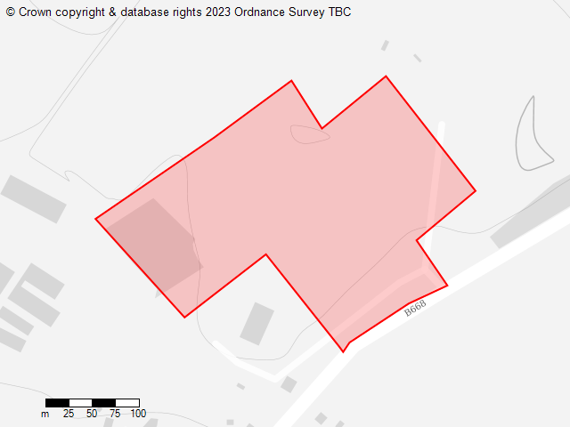

This site was not passed for the following reason:

“Suitability (2a)

Site does not pass 2a as it has 8.61% overlap with Priority Habitat - deciduous woodland.”

There are two points to be made here: firstly, the rejection of the whole site because less than 10% had a priority habitat designation that could have been omitted from any development scheme appears to suggest that there was a lack of rationality given to the site selection process especially in this case were the remainder of the site is previously developed and easily distinguishable from the area of woodland. Such an approach effectively devalues the whole of the SA as it casts doubt upon any reliability that could be attached to it as an analytical tool forming a reliable part of the evidence base.

To establish the area of woodland that is claimed to be affected an overlay of the area assessed has be placed over a Google map satellite image of the site (Figure 2 - below). This clearly identifies the area of woodland that falls within the area assessed lying to the north west of the site that has planning permission for residential development.

Figure 3 shows the proposed layout for development shared with the Council in Appendix 1 of the Reg 18 consultation submitted on behalf of |Hereward Homes (Greetham) Ltd that clearly shows the proposed allocation sought would not impact on the area of woodland (or insofar as the scheme is illustrative and shows the extent of woodland and of development indicatively).

1. Overlay of site assessed and satellite image

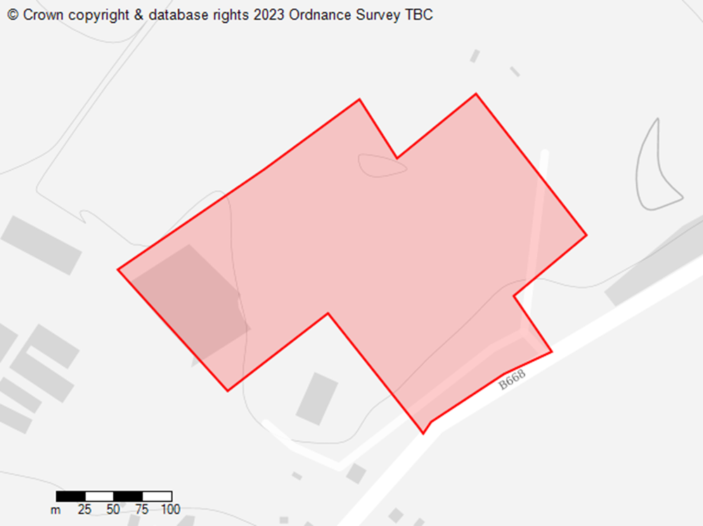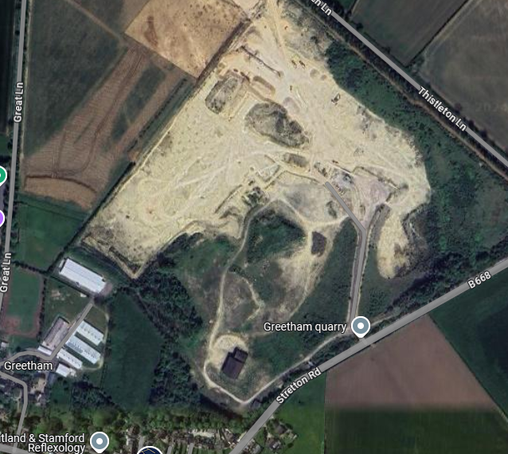

1. Reg 18 submission

For clarity Figure 4 below provides a clear red line denoting the area being proposed for allocation and shows that it does not include the woodland that was the sole reason for the Council excluding this site from further consideration.

Given the size of the previously developed land in the quarry the existence of a small area of woodland that was explicitly not proposed for built development cannot be regarded as a reasonable reason to reject the location as suitable in principle for development.

1. Red line of proposed development area

### Results of Landscape Sensitivity Report

This assessment did not assess parcels of land that were being promoted for development and also did not assess parcels based upon landscape features. For Greetham the assessment included Phase 1 of the Quarry and a part of land that forms Phase 2 of the Quarry development. This is labelled GRE3 and is shown on the extract below in Figure 5.

1. Extract from Landscape Sensitivity Report to Development

The area of GRE3 is assessed as Medium to low sensitivity to both housing and employment development. This report concludes the following impacts for both Housing and Employment development:

“Summary and mitigation potential Housing Development: The parcel displays a low degree of sensitivity primarily reflecting its primary use as an active quarry and associated screening belts. Some limited character and visual value may be experienced towards its outer boundary by established trees and hedgerows, but these are not of significant value outside their screening functions. The parcel is not important in maintaining a visual separation between the village and other settlements. The parcel generally remains disconnected visually from the historic core of Greetham, consequent to location and screening belt of the quarry block planting. Notwithstanding poor connectivity to existing settlement form **housing development within the parcel would not therefore present significantly harmful visual impacts in the wider landscape context of Greetham**, primarily by way of low surface heights within the workings and established screening. **Existing ecological and geodiversity value of the study parcel could be enhanced significantly by landscaping and integrated Green Infrastructure elements pursuant to housing development**.”

### **Conclusion on the exclusion of land at Greetham Quarry at stage 2a of the site selection process.**

The above analysis clearly demonstrates that the site which is being promoting has been incorrectly excluded at stage 2a. The area being promoted (rather than the area that was assessed) did not impact upon the small area of established deciduous woodland to the north of Phase 1 (which has planning permission).

The site proposed for allocation (Phase 2) does not include 8% deciduous woodland and would not result in the loss of deciduous woodland.

In fact, the Landscape Assessment concluded that the area had medium to low sensitivity to development and could actually be developed to deliver specific and significant enhancements to the ecological and geodiversity value of the site by landscaping and integrated Green Infrastructure elements pursuant to housing development.

Given the clarification regarding that there would be no impact on the deciduous woodland and the fact that development would only have a medium to low landscape impact while delivering significant enhancements it is strongly suggested that the Council re-examine the potential for this site to be allocated for residential development and small-scale employment provision to meet the needs of a local company.